Praised be the Incarnate Word



Sisters of Charity of the Incarnate Word (CCVI)

Villa de Matel Convent

Houston, Texas

Sr. Mary Anne Purcell, CCVI
(1893-1952)

1892 Born Ellen Purcell in County Tipperary, Ireland
Daughter of James Purcell and Mary Dwyer

1911, Oct. 14 Enters the Congregation of Sisters of Charity of the Incarnate Word

1912, May 4 Receives the Habit

1914, May 4 Professes First Vows in the Congregation, Galveston

1919, May 4 Professes Final Vows in Galveston, Texas

Missions in which Sr. M. Anne served:

1922 St. Mary’s Infirmary in Galveston, Texas

1925 Hotel Dieu Hospital in Beaumont, Texas; Nursing

1931 St. Bernardine Hospital in San Bernardino, California; Nursing

1936 St. Therese Hospital in Beaumont, Texas; Nursing

1937 Serves again at Hotel Dieu Hospital as Procurator

1939 St. Therese Hospital; Procurator

1941 Sacristan at Chapel of St. Bernardine Hospital in San Bernardino, California

1952 Dies; buried in San Bernardino, California

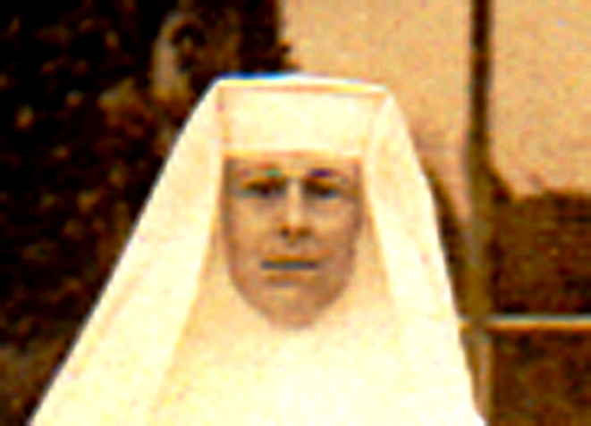

Sr. Mary Anne Purcell
1912

